Delhi Regional Neighborhoods

# Introduction

There a primarily 4 regions of Delhi, India, namely east, west, north and south. These locations are more than just geographical in nature, these locations have a lot of significance to the people who live in it. Whether it be the type of restaurants or the rent they must pay, each region regards themselves as a unique corner of Delhi.

# Problem Statement

When one finds themselves in the precarious situation of moving, they want to move within their region, but some external factors may cause the move to be to a different region all together. This may be a very stressful task and people like to stay in their comfort zones. The problem I wish to solve is finding neighborhoods like the one you currently reside in regions other than yours.

# Data

A list of neighborhoods in Delhi along with their geographical locations needs to be collected. Along with this information regarding the venues near a neighborhood.

The data for the neighborhoods in Delhi was scrapped from Wikipedia, <https://en.wikipedia.org/wiki/Category:Neighbourhoods_in_Delhi>.

After that, using the Foursquare API data for the venues near these neighborhoods was collected (top 10 venues in a radius of 500 meters).

The top 10 types of Restaurants (Indian, South India, Asian, Thai, Fast Food etc.) across all the neighborhoods were selected.

# Methodology

After an initial cleaning of outliers from the scrapping of the Wikipedia page. A list of all neighborhoods along with their coordinates was generated.

The top 10 venues within a radius of 500 meters were selected for each neighborhood. This number was selected after testing it for multiple known location with different combinations such as top 50 and 5000 meters. The chosen number reflects the personality of the neighborhood. Since the neighborhoods are often closer together the distance and number of top venues was chosen to be relatively small.

All the various types of restaurants were then evaluated to find their popularity. The top 10 were chosen to segment the neighborhoods.

Clusters were created to identify similar neighborhoods based on the type of restaurants in that region, similarly the neighborhoods were segmented into geographical zones based on their coordinates.

An Info Guide was created by merging the two clustering approaches. Finally, an interface was created where a user can enter any location in Delhi and a neighborhood closest to the location is identified along with its region, east, west, south or north. Then all the similar neighborhoods in the region other than the present one are shown on a map along with the present location.

# Results

All the neighborhoods in Delhi

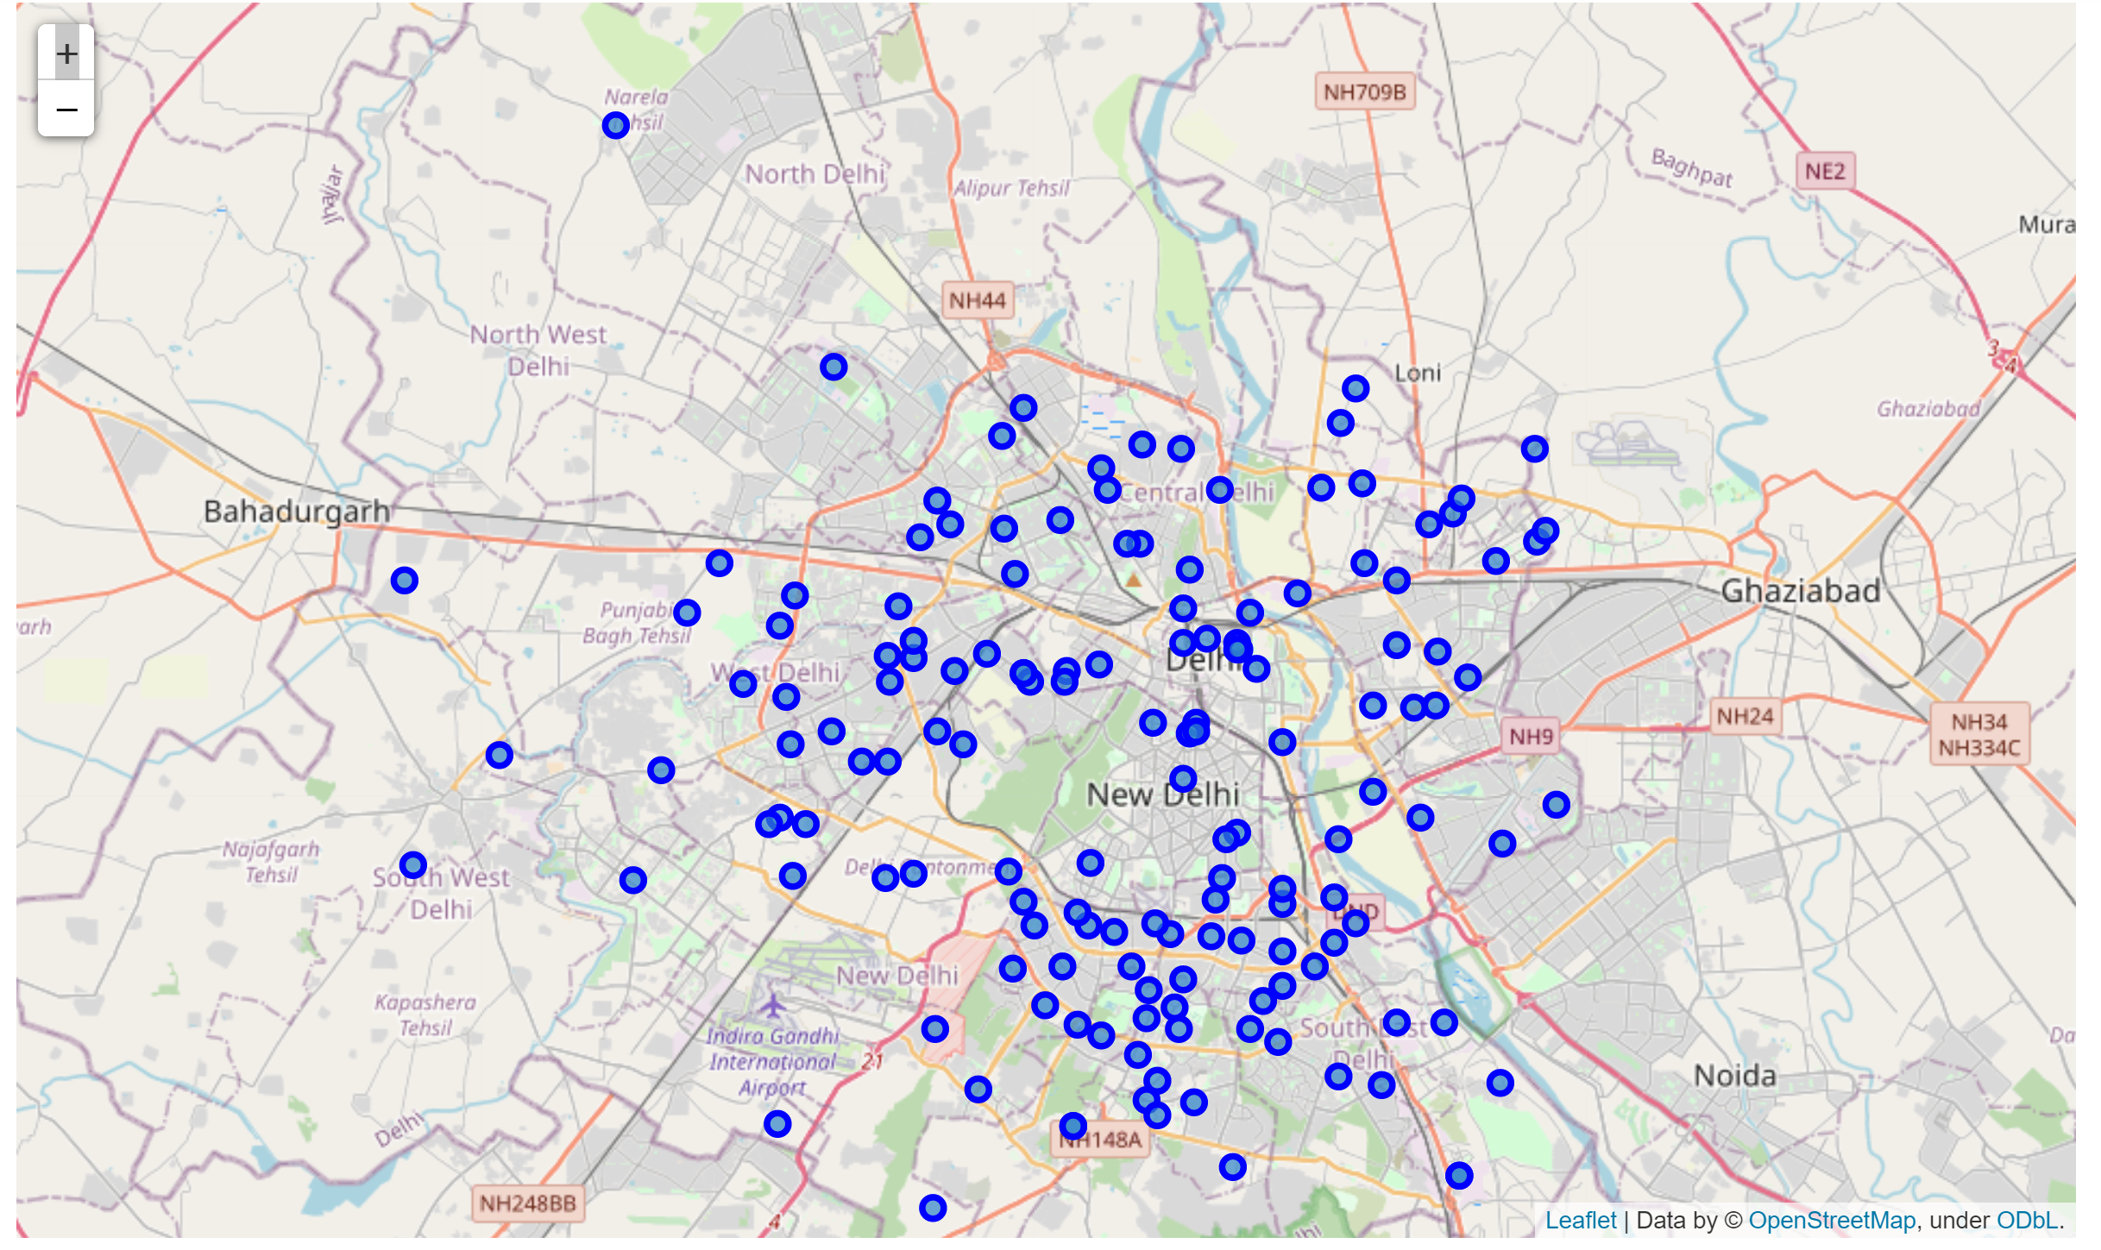

Restaurant Popularity by Type

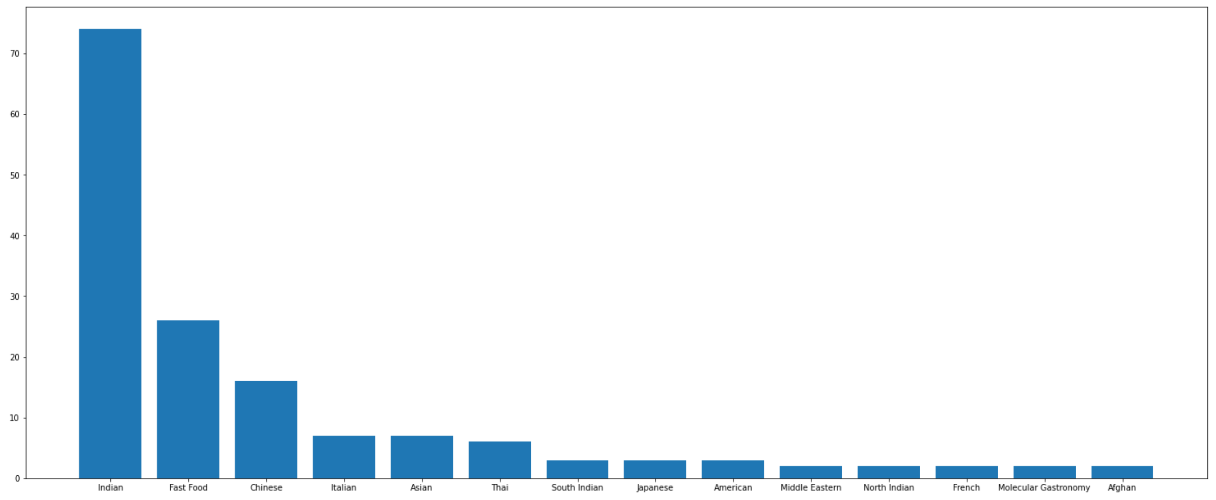

Region Clustering Based on The Type of Restaurants (10 Clusters)

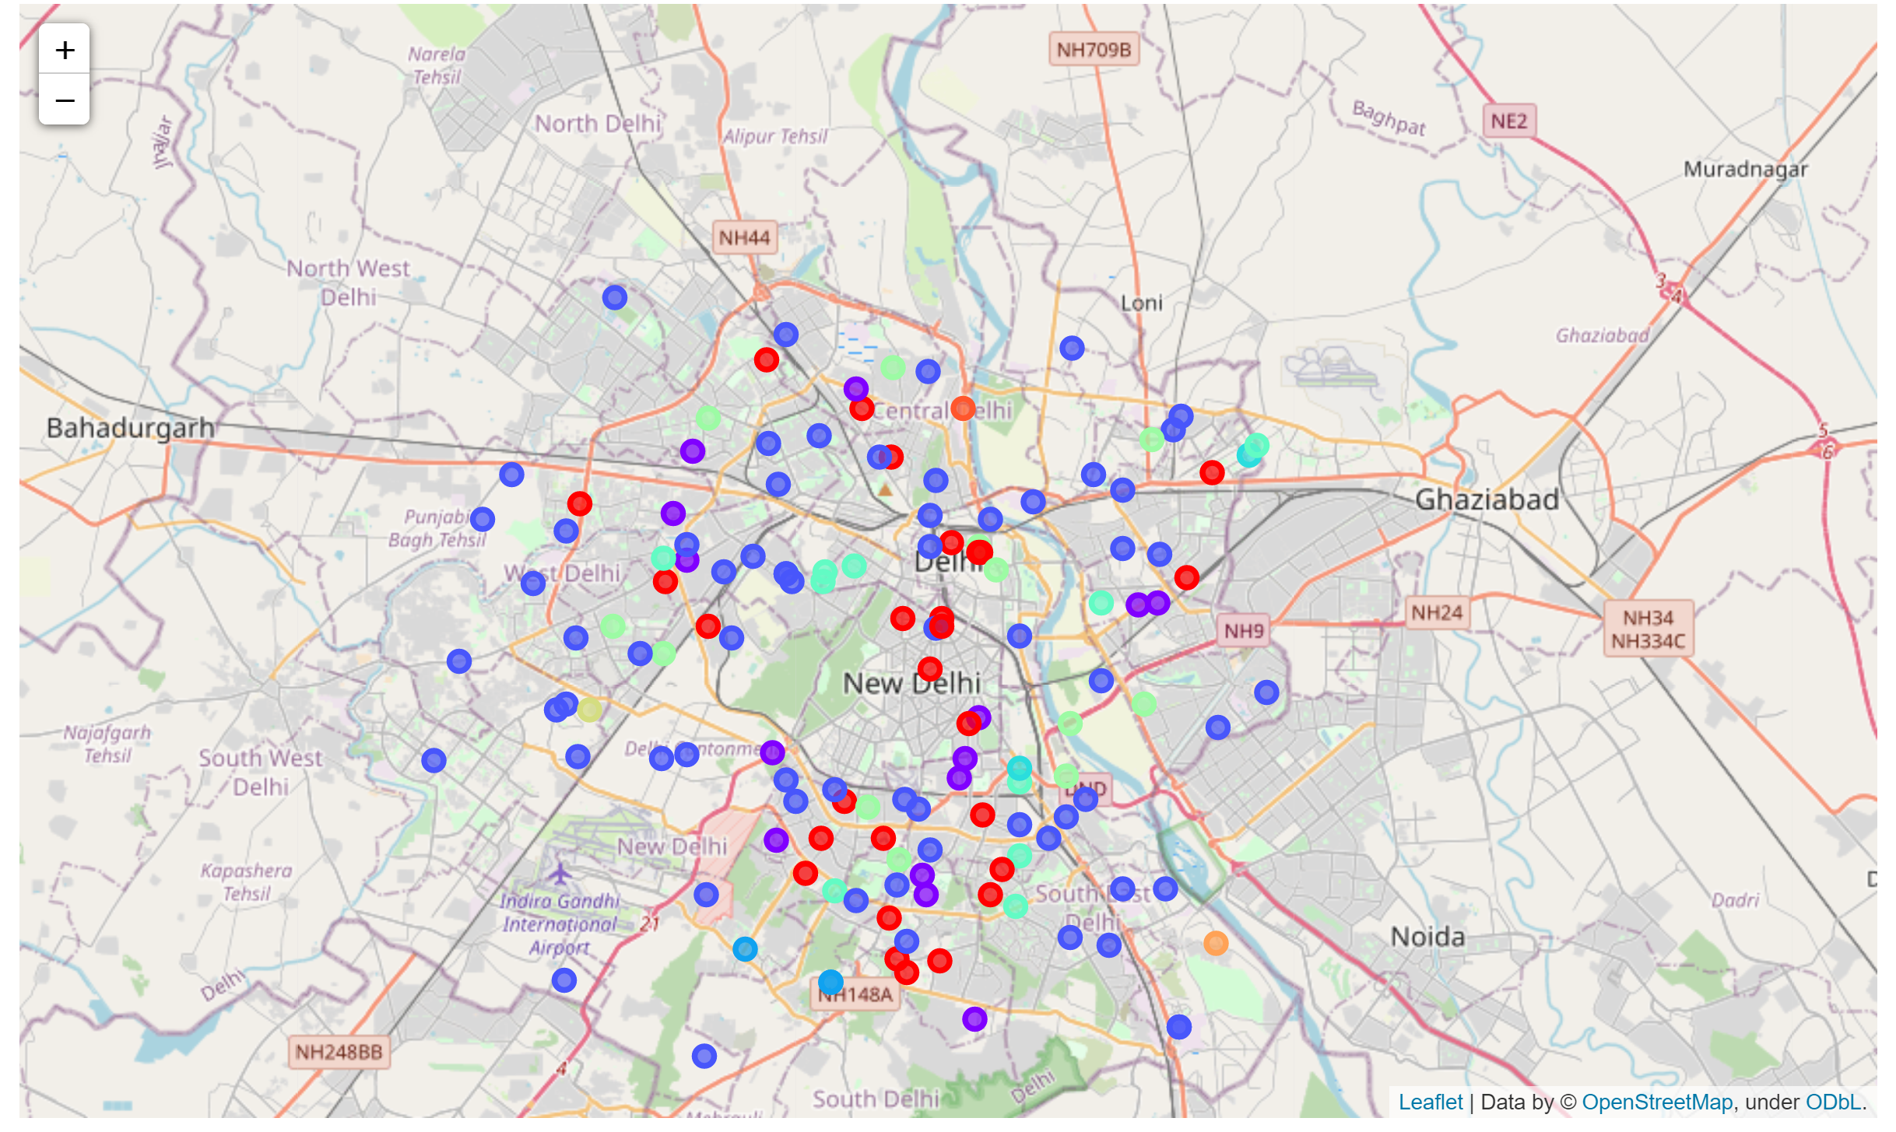

Region Clustering Based on Geographical Location

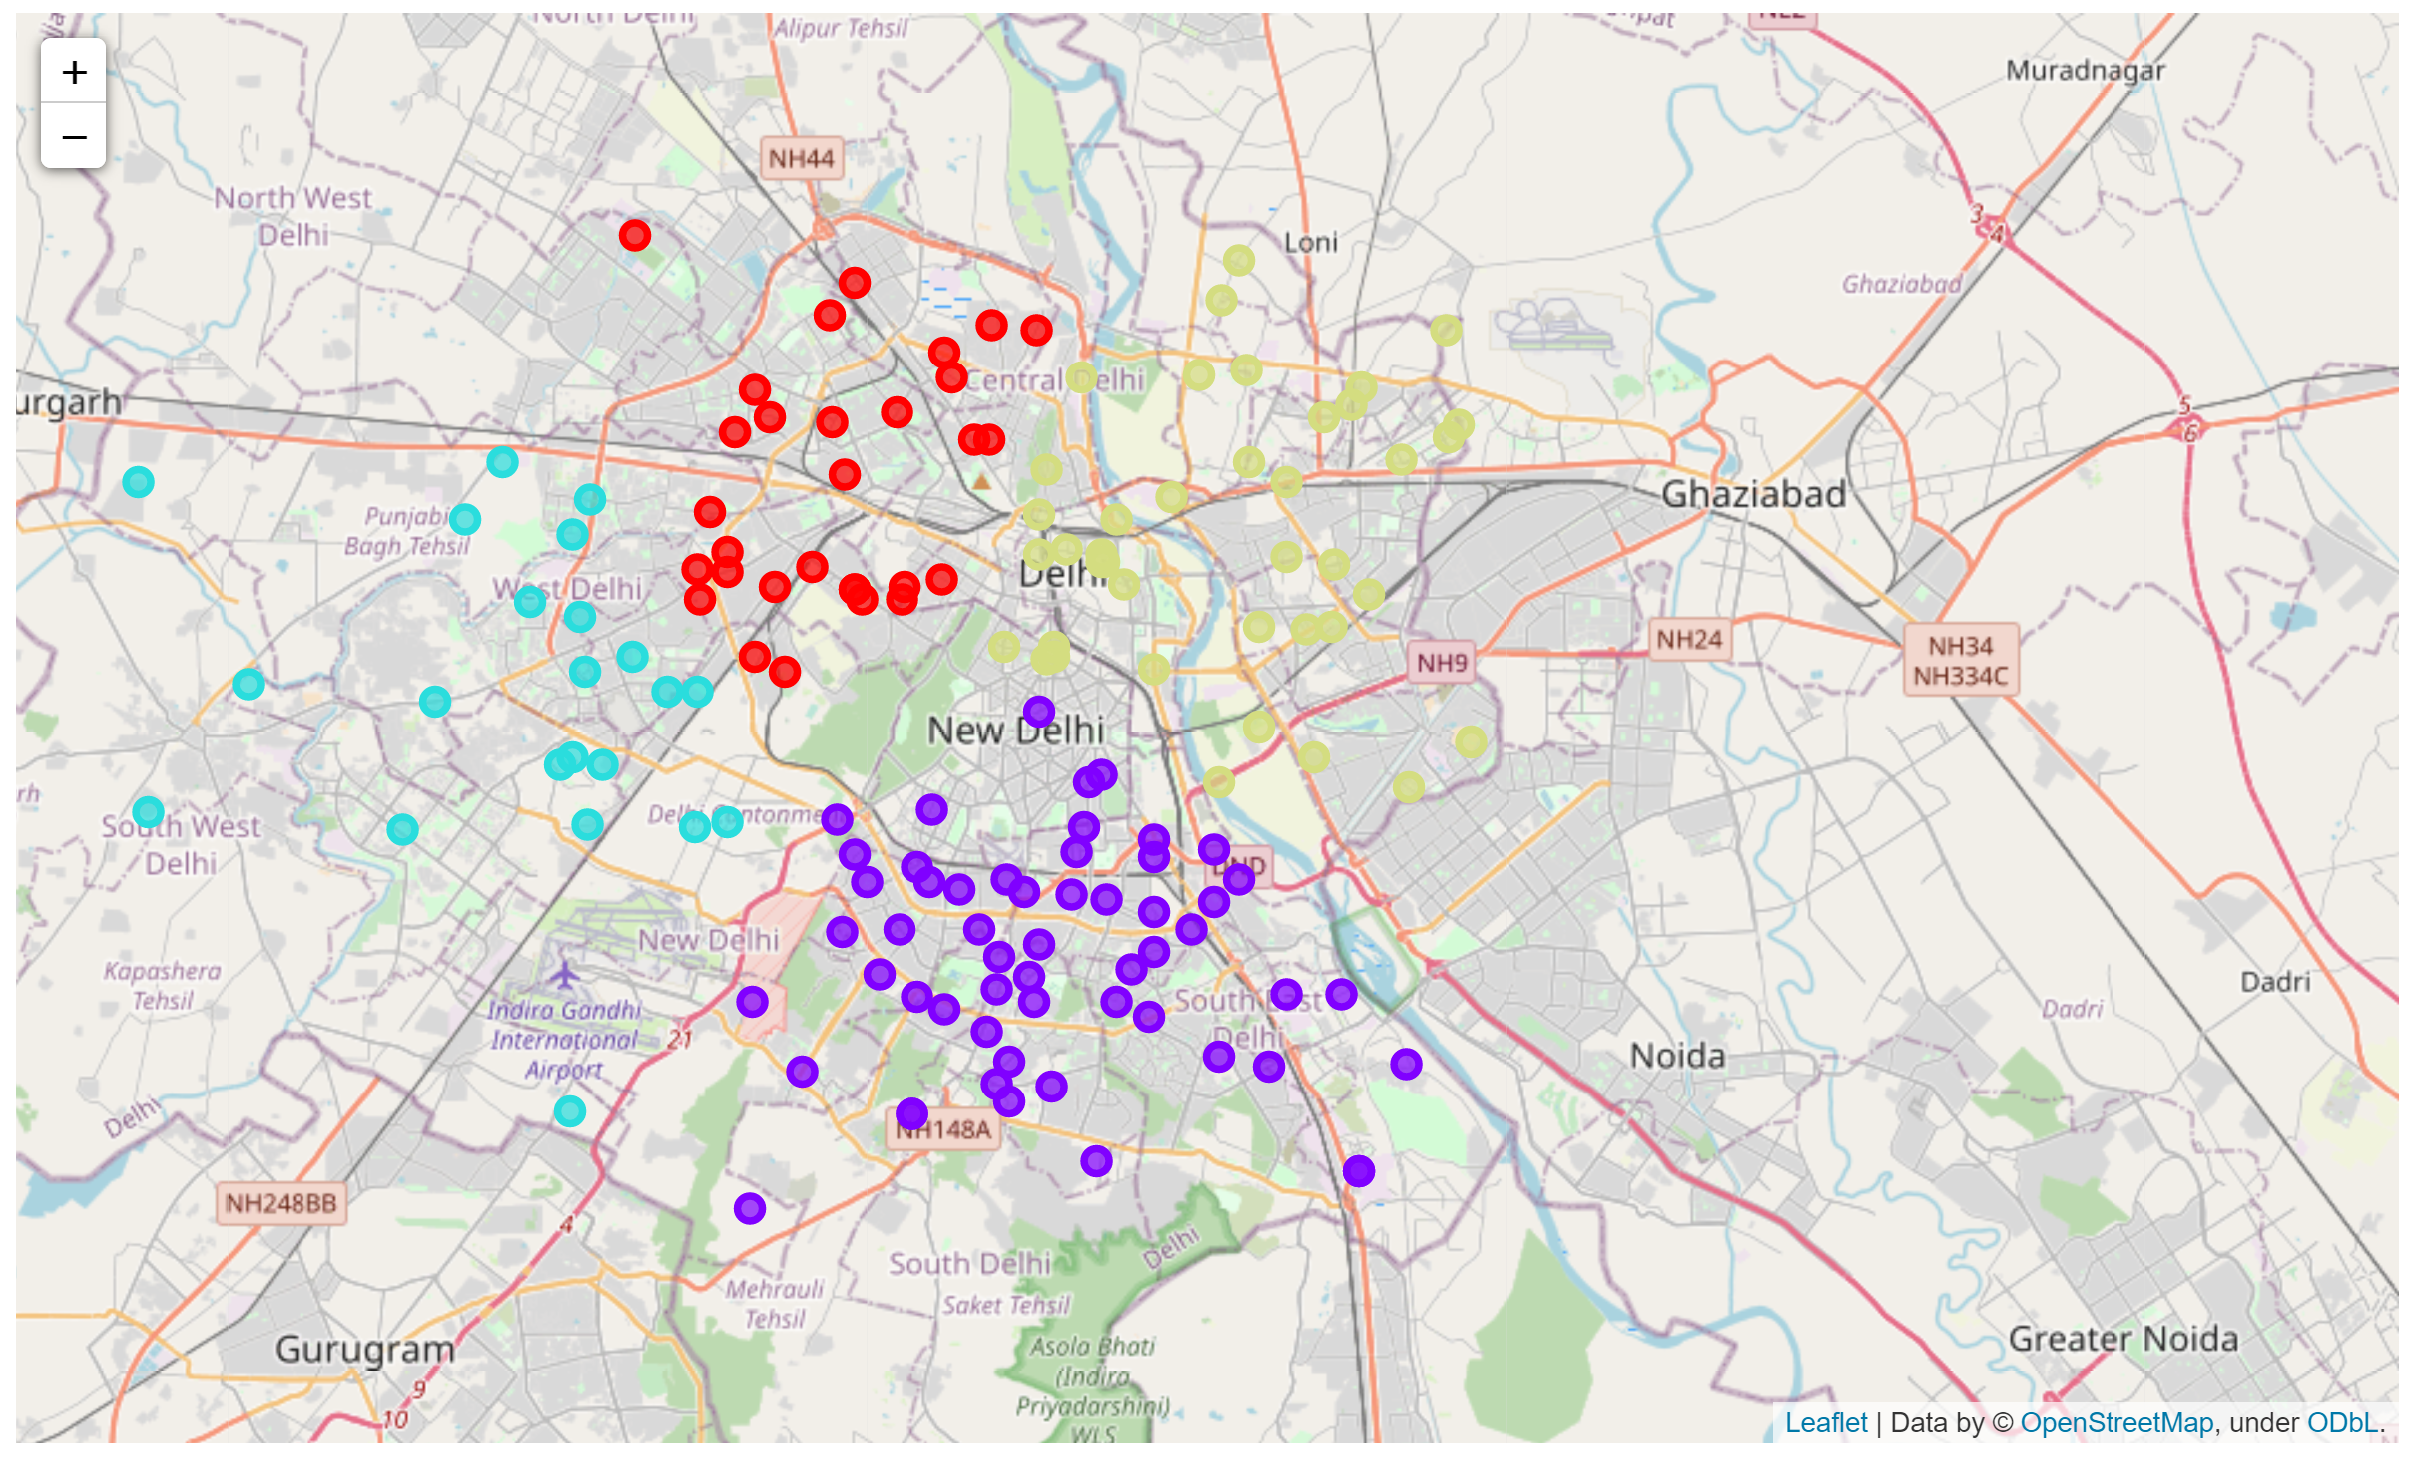

Final Output for a User Define Input

User Defined Location "ashok vihar"

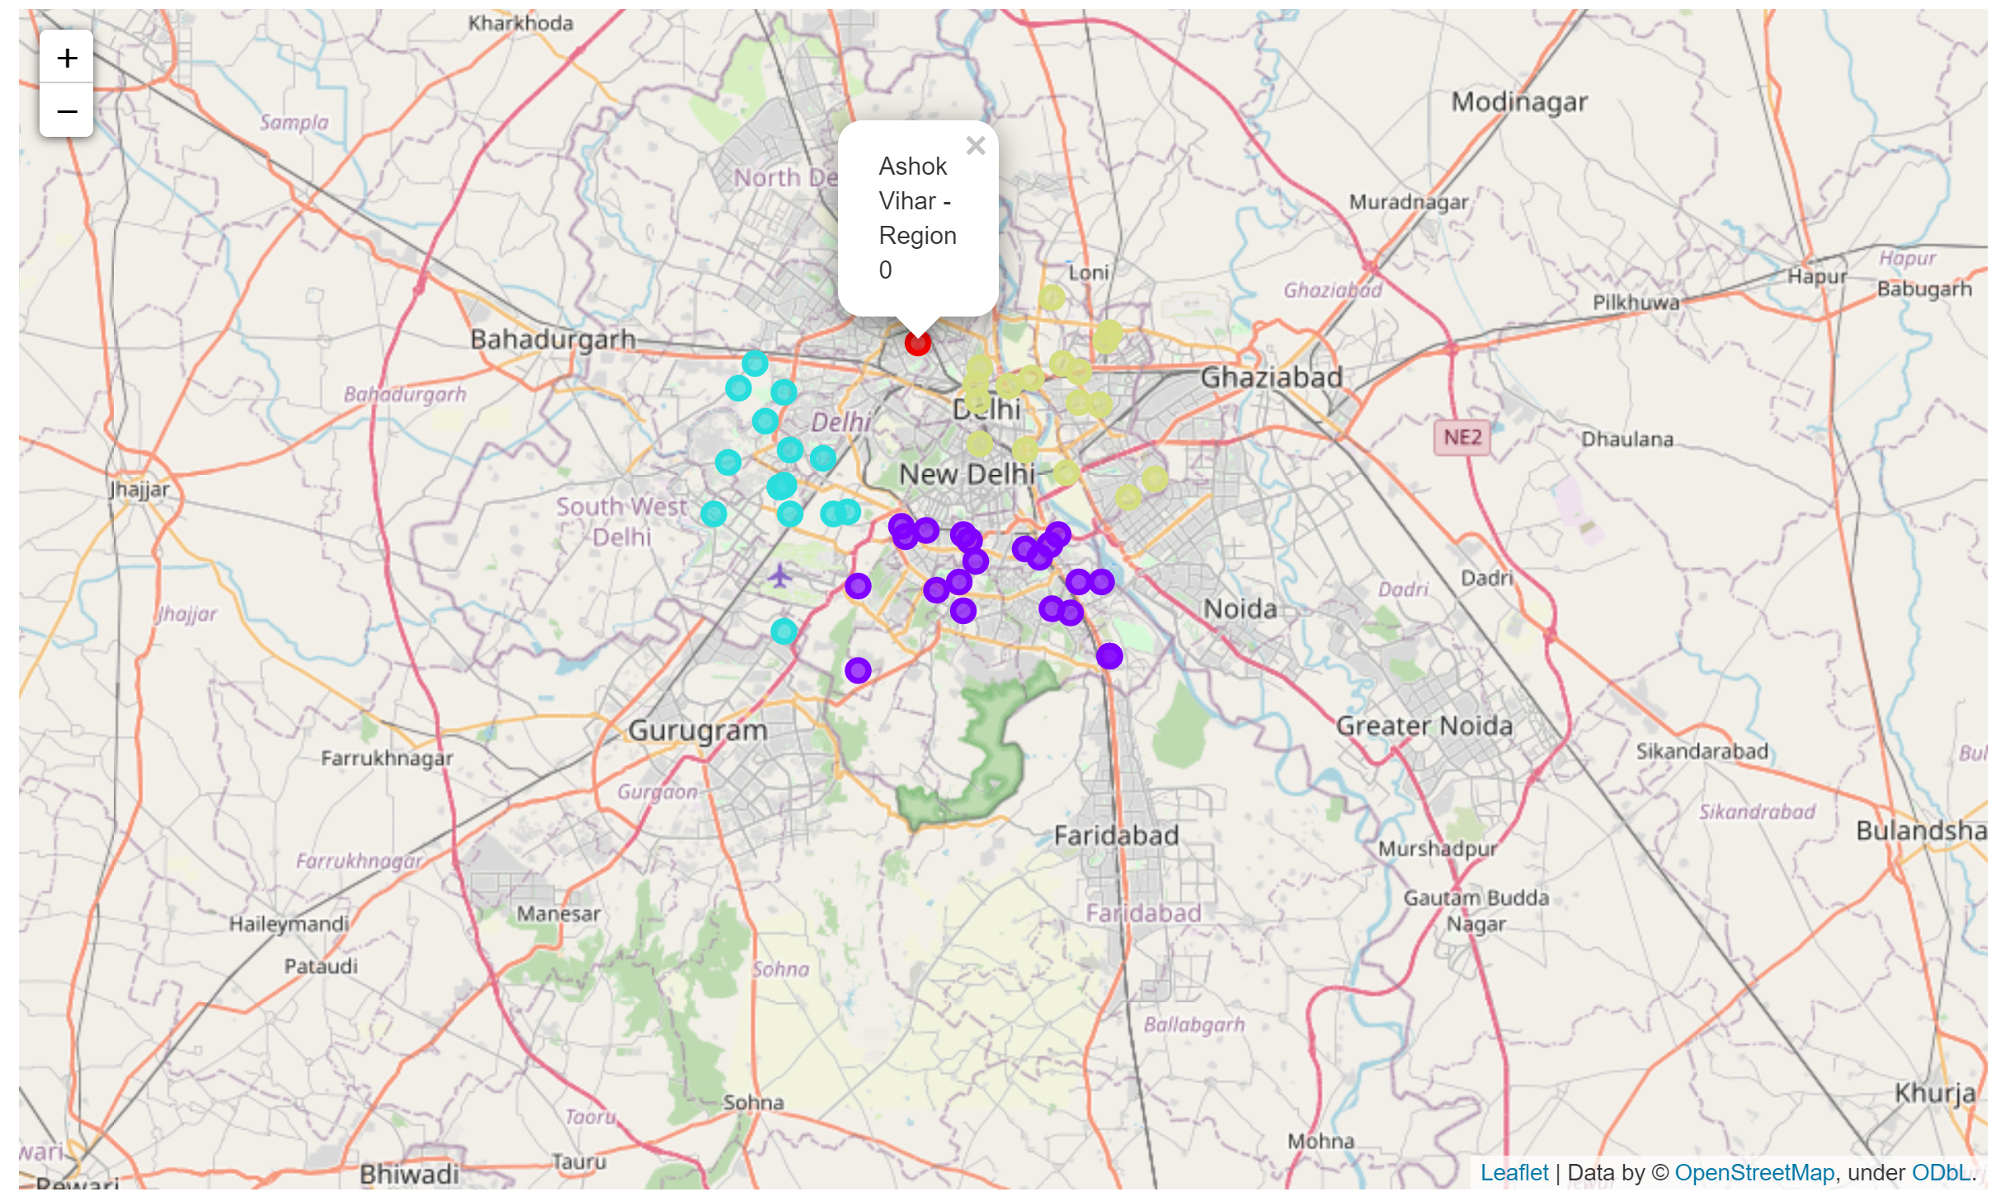

# Observations

The biggest Cluster was the one where the neighborhoods had most of the restaurant types in their vicinity. Since this does not provide a fine enough sieve to distinguish between the neighborhoods more type of venues can be included.

# Conclusion/Areas of Improvement

The type of restaurant is a helpful way to identify a similar region, but the quality of the restaurant is still unknown. More variables can be added to the clustering such as the average ratings. Adding to it the regions can be clustered on other amenities too such as ATMs. Finally, the user can be asked for their preferences, such as preferred restaurants etc.

While the results show the similar neighborhoods in other regions very little is still known about the new locations. A more informative UI is needed to explore the idea.